1. Install jenkins and run jenkins on port number 8081.

Prerequisite to Install jenkins is java.

Download jenkins Repo:

=====================

sudo wget -O /etc/yum.repos.d/jenkins.repo https://pkg.jenkins.io/redhat-stable/jenkins.repo

Import the jenkins key:

======================

sudo rpm --import https://pkg.jenkins.io/redhat-stable/jenkins.io-2023.key

Update ec2:

==========

sudo yum upgrade

Add required dependencies for the jenkins package:

=================================================

sudo amazon-linux-extras install java-openjdk11

Install Jenkins:

===============

sudo yum install Jenkins



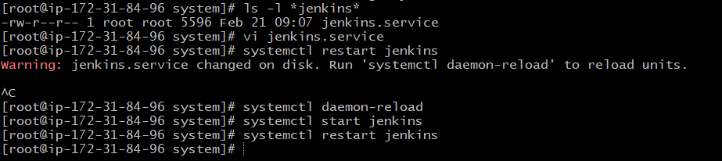

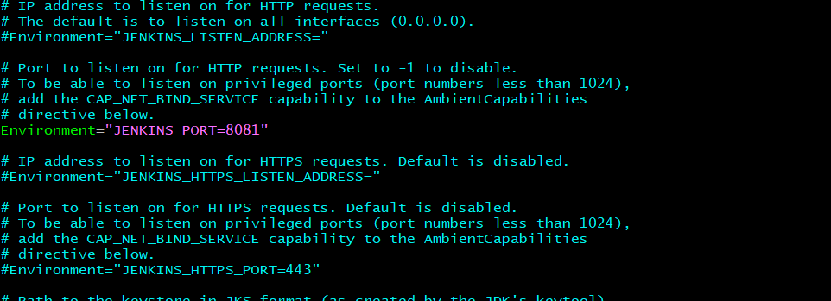

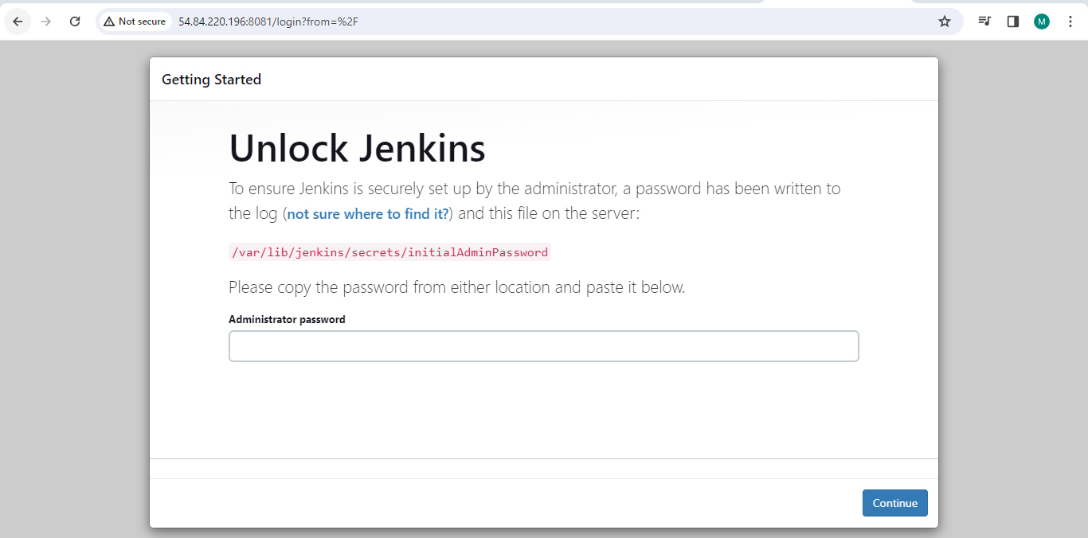

1. Secure Jenkins server

Delete initialadminpassword to secure Jenkins

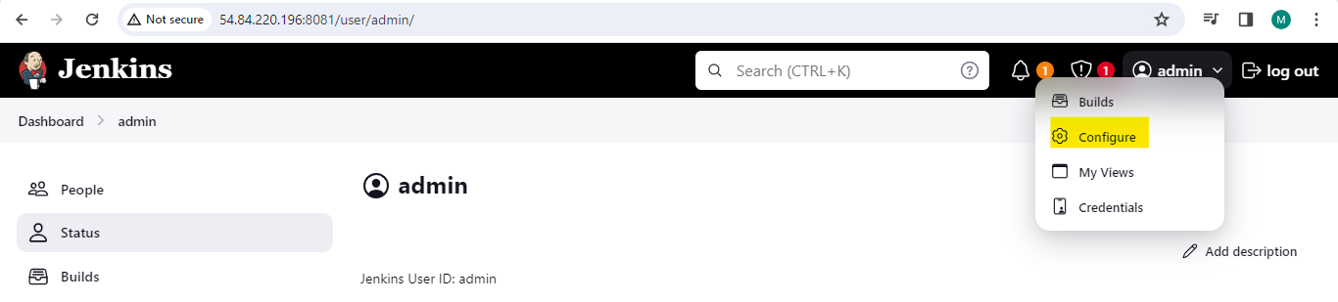

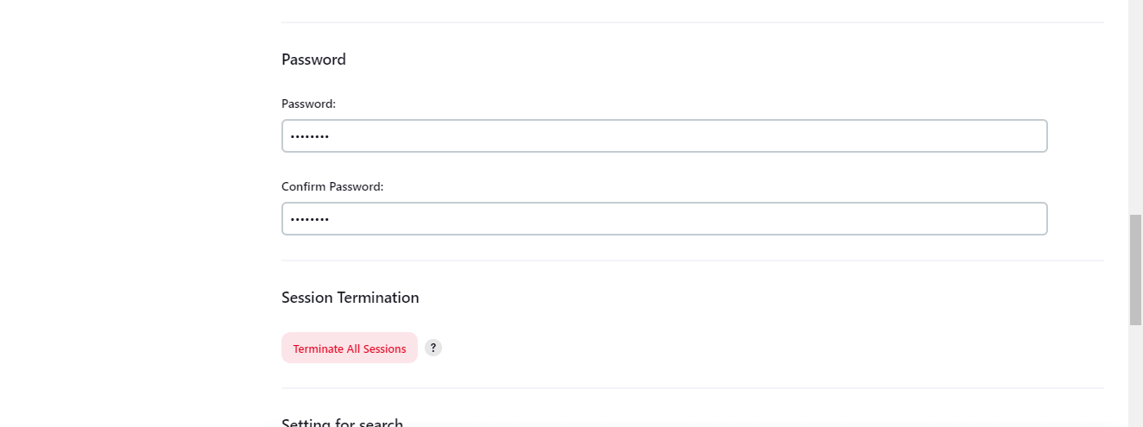



1. Create users called Devops, Testing in Jenkins with Limited access.

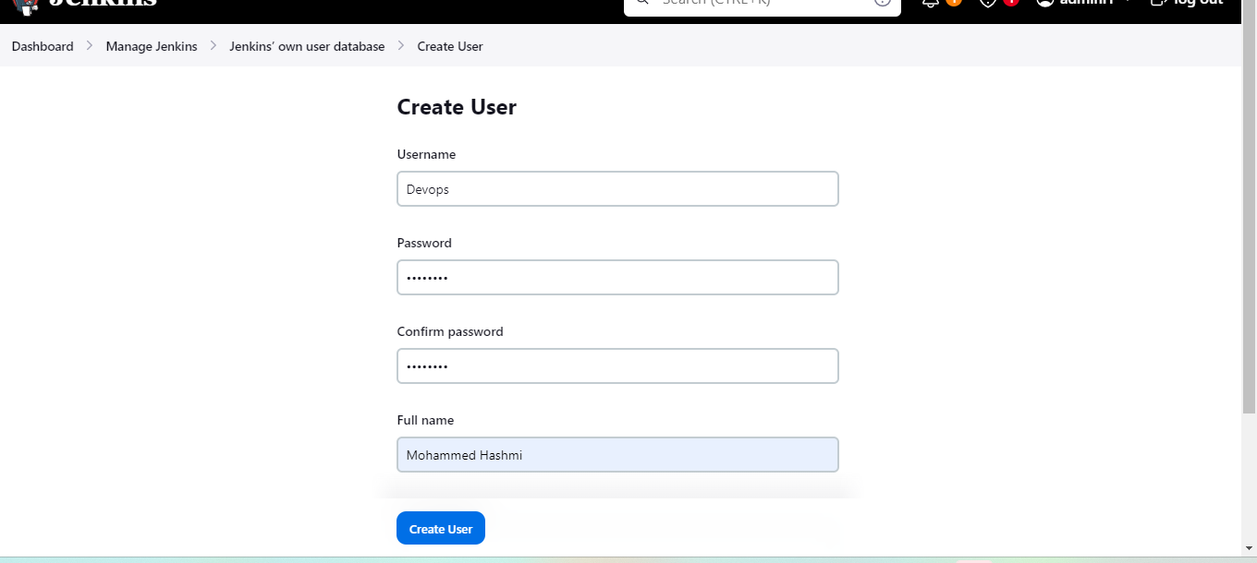

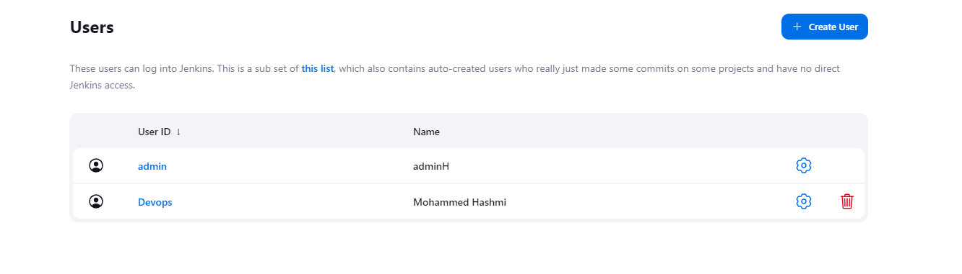

1. Configure labels and restrict the jobs to execute based on label only.

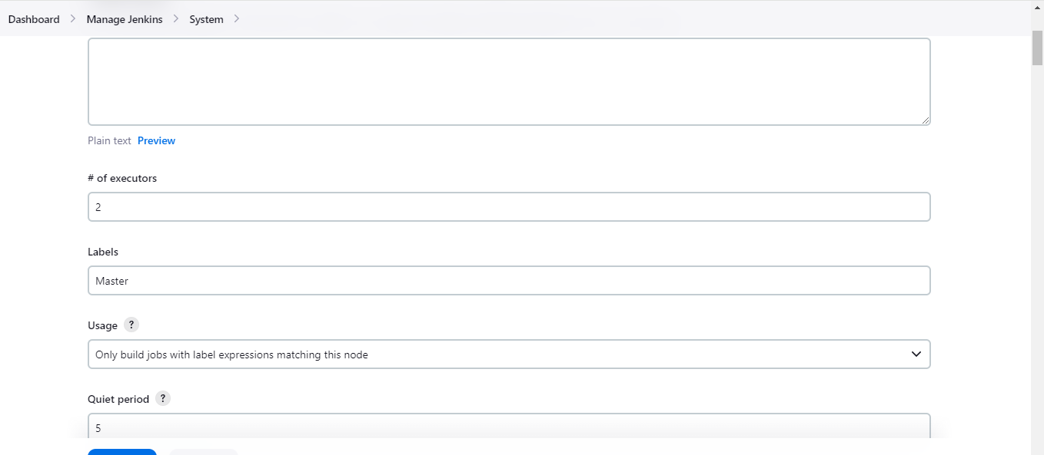

1. Create Three sample jobs using the below URL. <https://github.com/betawins/sabear_simplecutomerapp.git>

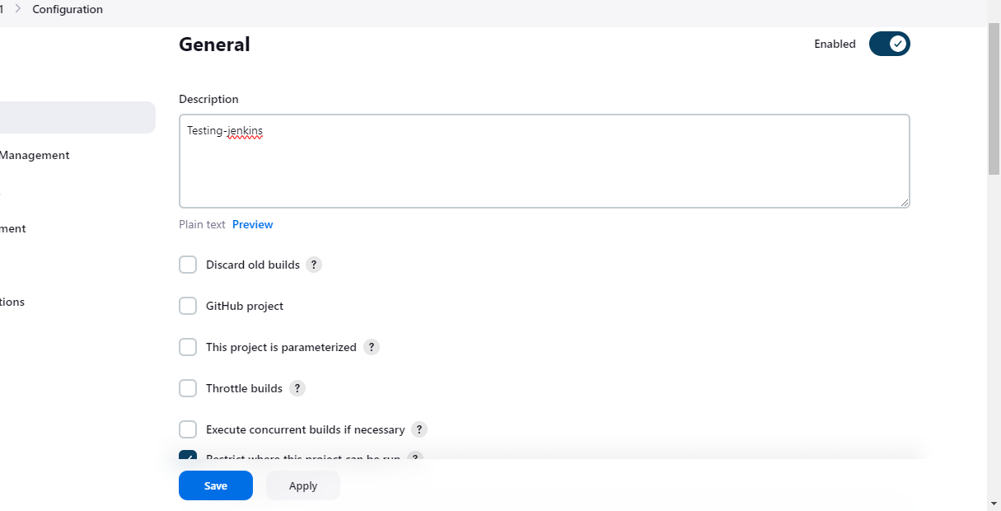

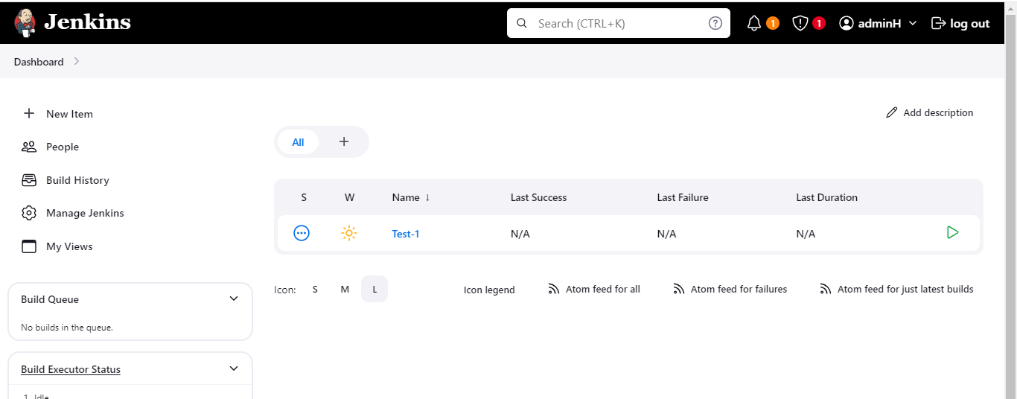

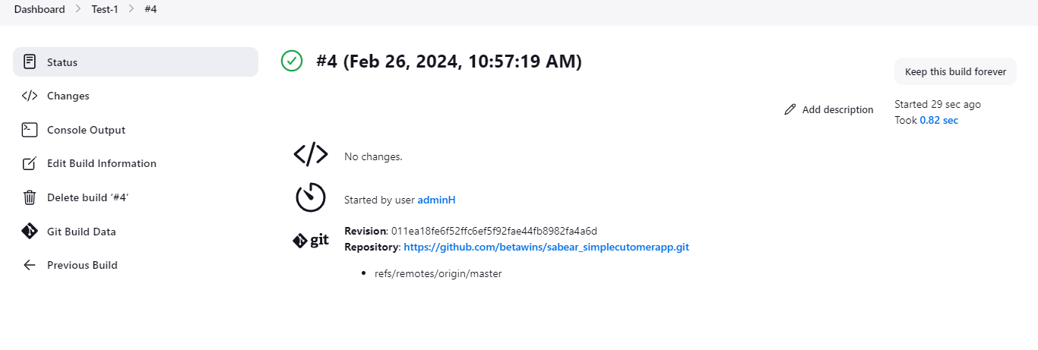



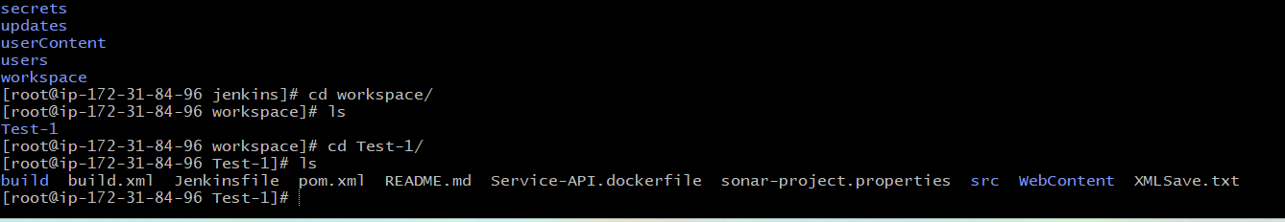

1. Create one jenkins job using git hub Private repository.

Github—setting—Developers settings

